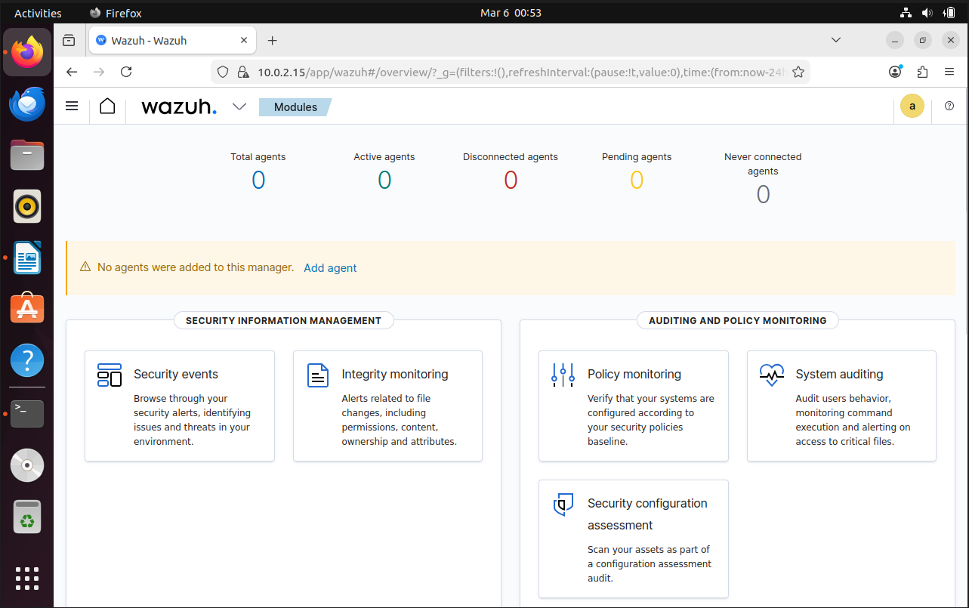
Wazuh Dashboard
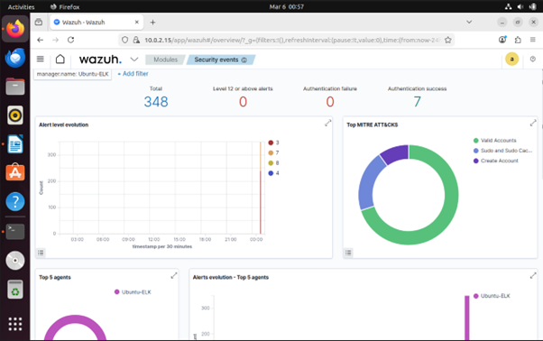
Security Dashboard


MITRE attack

Agents

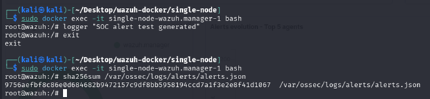
Logs Generated for Alerts.

